**Instructions for abstract preparation for GAeF START 2025**

J.L. First1, P.L. Second2 and J.C. Third2

1Department of ……, University of Somewhere, City, Postcode, Country

2Department of …., University of Elsewhere, City, Postcode, Country

Keywords: first, second, third, fourth, fifth.

Presenting author email: j.first@somewhere.edu

The abstract should be in double column (like this example) and ONE page long (any additional page will be automatically deleted). Use A4 page set-up and make all margins (top, bottom, left, right) 20 mm wide. Start typing text about 7cm from the top of the page. Use 10 pt Calibri font (except for the title which should be in 12 pt bold and in sentence case). Centre the title, the authors’ names, the addresses, and keywords and contact email address. Please compose a title that clearly and succinctly describes the content of your work, in order to maximise its impact.

Start each paragraph, except the first, with an indent. Justify the body of the text both left and right. Do not use page numbers. Uniformity of abstract style makes the work much easier to digest! Keywords are there to draw attention to your abstract, and to help the organisers allocate the presentation to the most appropriate session.

Use clear English to write your abstract, with an emphasis on describing what is new and why it should attract the attention of the audience.

Figures can be in colour or in black and white. Ensure that Figures and Tables have a caption and that they are numbered consecutively.

Table 1. Comparison between theoretical predictions and experimental measurements.

|  |  |  |
| --- | --- | --- |
| Month | Measured density (μg/m3) | Predicted density (μg/m3) |
| Feb | 0.4 | 0.4711 |
| Jun | 2.4 | 1.528×104 |

References should be made in the style (Dickenson, 2005), Marr and Morrissey (2010) or as Curtis *et al* (1996). Examples of references are shown below. Leave a blank line above the list of references, and also above the acknowledgements.

Section headings can be used, but they do take up valuable space: the same can be said of equations.

**Abstract review**

The abstracts will be reviewed by the START 2025 organizing committee. Abstracts which do not fulfil the standards will be rejected. Please avoid submitting abstracts containing only future results.

Accepted abstracts will be provided to conference attendees.

Participants should not make requests for oral presentation of several papers on similar subjects. We recommend submitting only the most general paper for oral presentation and the others for poster presentation.

The abstract should be submitted in **pdf format** through the GAeF website (<https://www.info.gaef.de/start2025>). The deadline for abstract submission is **…. 2024**.

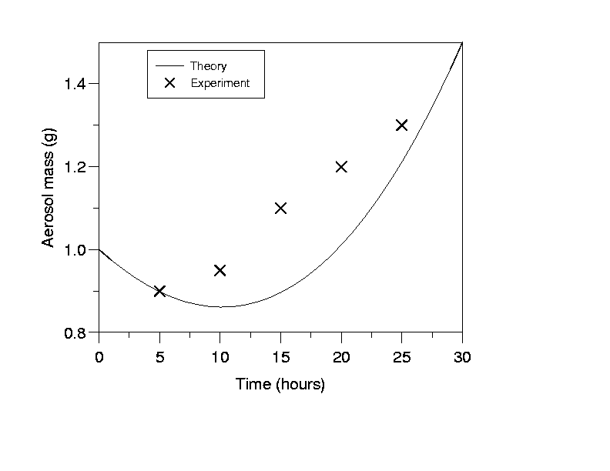

Figure 1. This is a comparison between theory and experimental data.

This work was supported by the National Council for Aerosol Research under grant JB/005.

Curtis, I., Hook, P., Morris, S. and Sumner, B. (1996) *Proc. 2nd Int. Conf. on Aerosols in the Atmosphere,* World Scientific.

Dickenson, B. (2005) *Acoustic fragmentation of aerosol agglomerates*, Manchester University Press.

Marr, J. and Morrissey, S. (2010) *Phys. Rev. Lett.* **210**, 123-126.